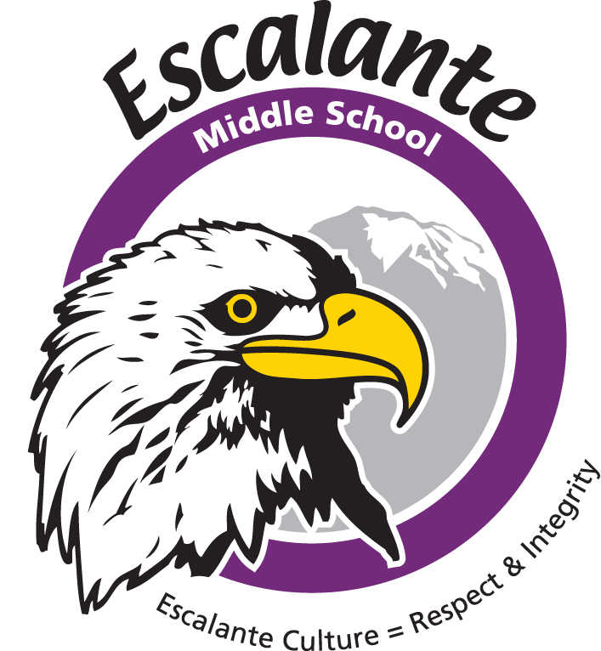

Jeremy Voss, Principal Tamara Glaser, Assistant Principal

Boys’ Basketball 2016

Date Day Opponent Place Time/Dpt

Oct 17 Monday First Day of Practice @ Escalante
Nov 1 Tues Cortez Escalante 4:00
Nov 3 Thurs Miller Escalante 4:00
Nov 8 Tues Bayfield *Bayfield 4:00/2:30
Nov 15 Tues Pagosa Escalante 4:00
Nov 17 Thurs Cortez Cortez 4:30/3:00
Nov 29 Tues Miller *Miller 4:00/3:00
Dec 1 Thurs Bayfield Escalante 4:00
Dec 8 Thurs Pagosa Pagosa 4:00/2:30
Dec 10 Sat A & B Tournament Hosted by Miller, details TBD

For all contests, C colors and C will play in the aux gym, and B and A will play in the main
gym. In the aux gym C colors play first followed by C. In the main gym B plays first
followed by A.

*C games @ Miller are played at Needham Elementary
*C games @ Bayfield are played at the Bayfield Primary School

